Cultural Events

Brock Soicher

**DU Arcade:**

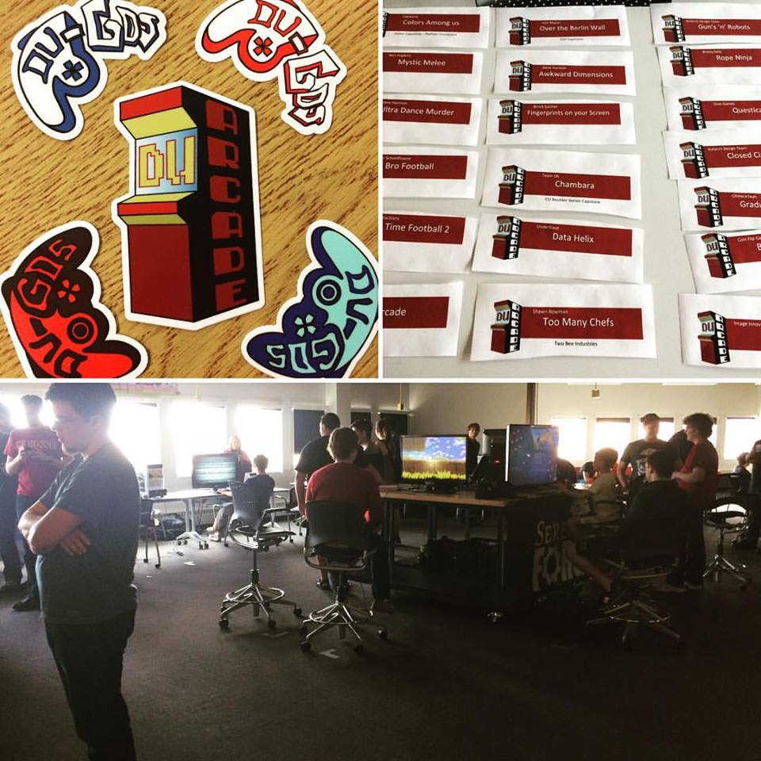

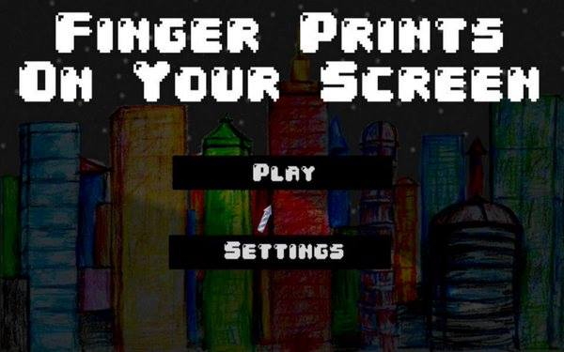

DU Arcade was an even that I helped host in April where we showcased almost 20 different video games made from Colorado developers. Amazingly, even though the event was a bit on the smaller side, it was actually the largest video game showcase in Colorado so far, and we are very proud of that. My game was also featured in the event (seen above). The idea behind the event was that we wanted to show not only bring games made in Colorado to a wider audience, but we also wanted to have DU be a large part in the video game community because DU is also the first university to offer a video game development degree (which I am pursuing).

The event itself started at 10am and we had all the developers set up at their respective booth and showed their games to viewers up until 3:30. One highlight of the event was the Serenity Forge booth which brought three different games, one of which has been publicly announced a mere few weeks ago. That being said, my favorite game that was displayed was a game called *Chambara*, which was made by students from UNC. In this game, the whole world is in black and white, but so are the players. It is a 1v1 melee game where you jump around a 3d environment to defeat the other player, but because you are the same color as your surroundings, you can easily blend in just by standing still in a spot that is the same color as you. It was very fun to both play and watch, and because *Chambara* will soon be released to help start up a game developer right out of school, the increased viewing from the event will surely help them out quite a deal.

And I think that aspect is what made the even such a success in my eyes. Even people like me who loves video games and tries to be present in the local community, many of the games here I would have never heard of, even though almost all the games were fun and polished. I even met a game developer who is only a junior in high school and has already published two video games, both of which seemed very high quality. I talked to him for a bit and talked about both of our past failings with making games, and I can feel like I can say that I even made a friend, which would have never been possible without the event.

The plan is that DU-GDS (DU Game Development Society) will have an expo every April to promote even more games and maybe even show off the finalized version of past games.

**Project Mapping Showcase:**

This event was essentially students from the Project Mapping club coming together one night in front of the Shwayder Art building to show off some of the projects they had been working on. As you can see in the photos it was not perfect because the light posts still made it a bit too bright for some of the projects, but you can still see the patterns projected onto the building. I also brought my own project to show off what it could do, and even though I was not able to use a projector (only one was brought), I found that my project worked extremely well on the trees because they were thick enough for the laser pointer to effectively show up, and it was an area away from the light posts that allowed the camera to very easy pick up a bright image. It was also cool to see other people use my app because so far the only people who had really seen it were the people in my class or my family when I tested it at home. By the end of the event there were about 6 people watching me draw using the trees, so I gave them the laser pointer and my phone for them to use the OSC, and people seemed to be having a really fun time and they took some photos, so it really showed that my app can bring some joy which I think is what everyone needs to see now and then.

The people who set up the event had a tricycle with a stable mount on the back because it made for an easy setup to place a projector and it is obviously very mobile. They plan on putting a generator on the back on the tricycle and another spot where you could also place a generator to give them the possibility to essentially have events like this wherever or whenever they would want and not have to rely on power outlets, extension cords, or having to even be stationary in case they wanted to do something special similar to the project shown in class with the car’s speed changing the image of a tiger that’s projected out the window.

All in all it was a very fun event just so I could see other people’s work, let them see mine, and talk about other types of digital art that they were passionate about.

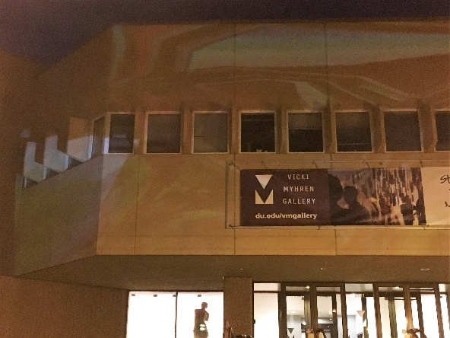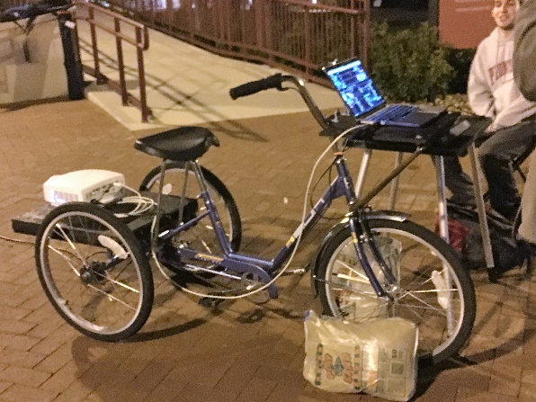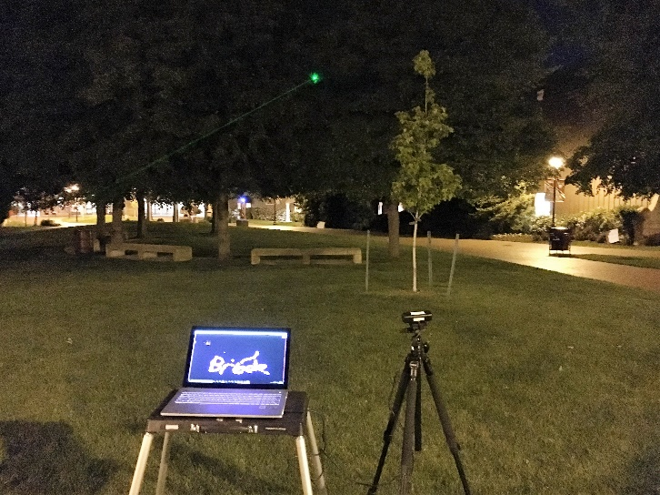

**EDP BFA- BA Exhibition & Annual Expo:**

This event was an annual event that the EDP department hosts to display student projects that have been made throughout the year. The thing that surprised me the most was how diverse all of the projects were. I thought that they would all be similar in some way, but I was completely off. There were video games designed for kids, art projects that used smoke, others that used lights and mirrors, and straight forward technology showcases. One cool project had a projector that sent out many images, but was right behind a bunch of mirrors, so it was reflected out to the other side of the mirrors and was a much sharper image that almost appeared 3d. It really did show how wide of a range the department works in and how the students essentially had an unlimited space for design and imagination.

My personal favorite piece was a technology project in which there was a box of sand, and a depth camera overhead and moving the sand would change the environment. I sadly didn’t take a photo of it (I included a photo of a very similar project so you can get the point), but essentially how it worked was that high mounds of sand would represent a piece of land, while low valleys of sand would represent rivers/lakes/oceans. So you could stack sand all in one spot, and the camera would register how tall the sand is and then project different light patterns to make it look as though it were land or water. I thought it was fascinating to play with because it was so responsive and the lights were ever changing so it was pretty much impossible to be bored with. I think that one stood out the most to me mostly because it seemed to be the most interesting use of technology that I saw and it seems like such a simple and genius idea at the same time.



